Observance of 'Sadbhavana Diwas' at COEP
The Birth Anniversary of our late Prime Minister of India, Shri Rajiv Gandhi, observed as "Sadbhavana Diwas" on 20th August nation-wide every year was also observed at College of Engineering Pune.
The “Sadhbhavana Day Pledge” taking ceremony was organized by the institute at 11am wherein the students, faculty and staff gathered near the Heritage Main Building of the institute and the “Sadhbhavana Day Pledge” was administered.
All present pledged saying that they would work for the emotional oneness and harmony of all the people of India regardless of caste, region, language and would resolve all differences through dialogue and constitutional means without resorting to violence.
Below are few glimpses of the “Sadhbhavana Day Pledge” taking ceremony
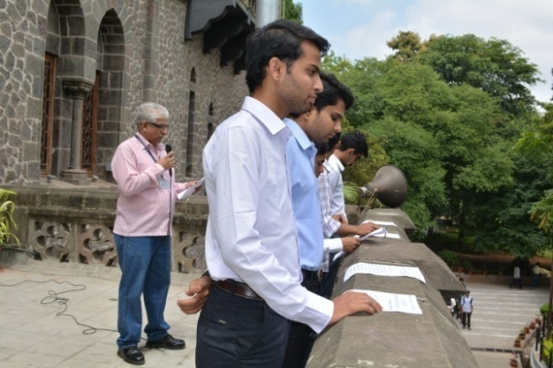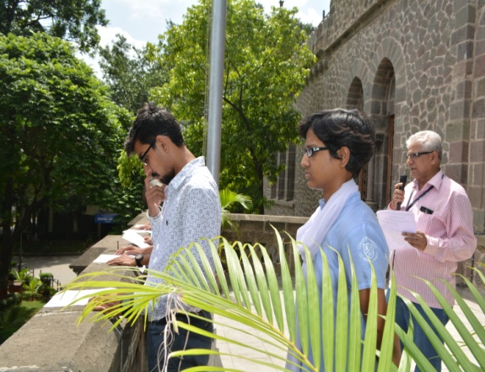
Programme coordinator, Dr. P. R. Dhamangaonkar & student representatives administering the “Sadhbhavana Day Pledge” to all.

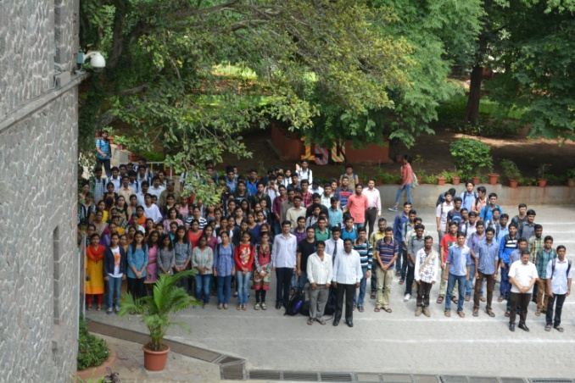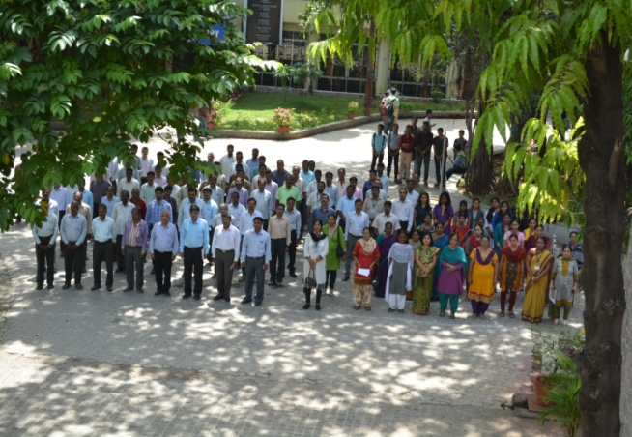
Students, faculty and staff taking the pledge

