PERSONAL RESUME
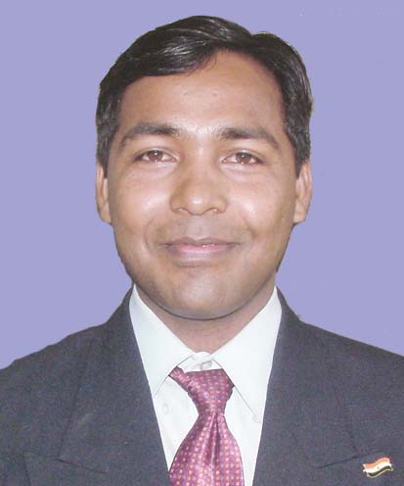
Brief Information: Dr. Rajaram Tukaram Ugale born in Pune, India on September 27, 1974. He received his B.E. Electrical and M.E. Electrical degree from University of Pune, in 1998 and 2002 respectively. He completed his Ph.D. in Sept. 2014 in the area of Permanent Magnet Synchronous Motors.
His employment experience includes three years in the Maharashtra State Electricity Board as a Jr. Engineer in Transmission and Distribution. He has joined College of Engineering Pune in June 2002 as a Lecturer in Electrical Engineering. Presently he is working as Assistant Professor and at College of Engineering Pune. His main research interest is Electrical Installations and System design, Electrical Machine Design, Power Conditioning.
In 2013-14 he got nomination for ‘Best teacher award nominee’ within COEP. In July 2015 he received "Cognizant Best Faculty Award: 2014-15". He has actively participated in the trainings and consultancy offered to the industry.

1. Complete name: Rajaram Tukaram Ugale
2. Post: Assistant Professor, Department of Electrical Engineering

3. Contact details
Address: Electrical Engineering Department
College of Engineering Pune-411005
Contact no: +91-020-25507134 (O)
Email: rtu.elec@coep.ac.in
Website: http://www.coep.org.in/index.php?profile=rtu.elec

Google Scholar Publications: https://scholar.google.com/citations?user=RX9Mh6YAAAAJ&hl=en

Scopus Publication details: https://www.scopus.com/authid/detail.uri?authorId=24400154700

Web of Science/Publons: https://publons.com/researcher/1454086/rajaram-ugale/
4. Qualifications:
1. Ph.D. in Electrical Engineering, completed from Govt. College of Engineering Pune [COEP], University of Pune. Research topic: Performance Enhancement of Line Start Permanent Magnet Synchronous Motor, on September 26, 2014.
2. Completed M. E. in Electrical Engineering (Power System) from Govt. College of Engineering Pune [COEP] under University of Pune on April 15, 2002.
3. Completed B. E. in Electrical Engineering from Govt. College of Engineering Pune [COEP] under University of Pune on July 25, 1998.
4. Completed Diploma in Electronics and Telecommunation Engineering from Govt. Polytechnic Pune [GPP], under Maharashtra State Board of Technical Education [MSBTE], Mumbai on August 12, 1993.

5. Experience:
1. Currently (since January 01, 2006) working as Assistant Professor in Electrical Engineering Department, at College of Engineering, Pune.
2. From 28 June 2002 to 31 December 2006 worked as Lecturer in Electrical Engineering Department, at College of Engineering, Pune (MPSC selection).
3. From 19 July 1999 to 27 June 2002 worked as Junior Engineer, (Transmisson and Distribution), Sawantwadi subdivision, Maharashtra State Electricity Board (MSEB).

6. Awards and Honors Received:

[1]. The paper selected as "Best Paper" and received first prize in the conference.
R. T. Ugale and B. N.Chaudhari, "Behavior of line start permanent magnet synchronous motor under unbalanced supply", Energy conversion - PCID-2008, Fourth National Conference on Cutting edge technology on Power Conversion and Industrial Drives held at Bannari Amman Institute of Technology, Sathyamangalam, (Erode); Tamilnadu during Feb. 22-23, 2008.
[2]. The paper selected as "Best Paper" and received first prize in the conference.
Nagabhushan Rao and R. T. Ugale; Effect of short power Interruptions on the performance of line start permanent magnet synchronous Motor", National Level Technical Symposium, PRAGNYA'08, held at JNTU COE, Hyderabad, India, during March 3-4, 2008.
[3]. In Academic year 2014-15, received "Cognizant Best Faculty Award: 2014-15".
[4]. In Academic Year 2012-13, received “Best Teacher Nominee Award” among College of
Engineering Pune (COEP) faculty.
[5]. During academic 2018-19 received Mr Raj S. Iyer Award of Rs.25000/- from Alumni Association of College of Engineering Pune for Best working model project of Electrical Engineering Department titled, "Design and Development of Ultra compact power electronic drive for BLDC Motor for Agricultural application", to B. Tech. Project batch students Ashish Pisal (MIS 111505079), Bhushan Mahamuni (MIS 111505077), Sanath Poddar (MIS 111505049)and Shubham Pawar (MIS (MIS 141605009) and Guide- Dr. R. T. Ugale.
[6]. During academic year 2018-19 received Mr. Ananad Kanhere Prize for the Innovative Project titled, "Autonomous electrical three-wheeler development to drive on a pre-defined path-Development of robust autonomous steering and braking system" to M. Tech. Electrical Engineering (PEMD) dissertation student Mr. Sachin Jijabrao Patil (MIS no.121749015) and Guide- Dr. R. T. Ugale
[7]. Received a Rank 2 Certificate in M. E. Electrical Engineering (Power Systems) Exams
in Pune University held in December 2001..
[8]. Selected for NTS and NMS Scholarship in 1990.
[9]. Authors received INR 11,000/- Award/Honorarium from the conference committee for research contributions.
K. D. Mejari and R. T. Ugale, "Solid sate Circuit Breaker based fault and load management in 22 kV power distribution system”, 9th International conference on Switchgear and Control gear, SWICON 2015, held at The Hotel Lalit, Mumbai, during 26,27 Nov. 2015. [Organized by IEEMA and Supported by MHRD, TEQIP and IEC].

7. List of Publications (Journal/Conferences)/ Patents/ Grants received:
7.1 Journal papers: [08Nos]
[1]. R. T. Ugale and B. N. Chaudhari, “Performance enhancement of line start permanent magnet synchronous motor using a special consequent pole rotor,” IEEE Transactions on Energy Conversion, vol. 36, no. 3, pp. 1972-1982, September 2021 DOI: 10.1109/TEC.2020.3038725, Print ISSN 0885-8969, Electronic ISSN 1558-0059, Published online on 17 Nov. 2020.
[2]. Priyanka M. Golatgaonkar, Rajaram T. Ugale, Bhalchandra N. Chaudhari and Bhavesh A. Rathod, "Analysis and comparative evaluation of multi stack and a novel single stack poly phase transverse flux machines," Taylor & Francis Journal, Electric Power Components and Systems, vol.48, Issue.16-17, pp.1835-1847, May 2021. DOI doi.org/10.1080/15325008.2021.1890859, Published online on 22 March 2021.
[3]. Priyanka Golatgaonkar, Bhalchandra Chaudhari and Rajaram Ugale, " Torque ripple reduction in homopolar poly-phase transverse Flux machine", PEMD 2018 Conference paper published in IET The Journal of Engineering, vol.2019, Issue 17, pp.3553-3558, May 2019. DOI: 10.1049/joe.2018.8187, Online ISSN 2051-3305, Published online on 17 May 2019.
[4] R. T. Ugale, K. D. Mejari and B. N. Chaudhari, "Intermediate Voltage Variation based Interconnecting Transformer Design for Voltage and Phase Angle Control with Coupled field FEA Studies", IEEE Transactions on Industrial Electronics, vol. 65, no.8, pp. 6077-6088, August 2018. DOI 10.1109/TIE.2017.2784404, Print ISSN: 0278-0046, Electronic ISSN: 1557-9948, Published Online on 18 Dec. 2017.
[5] R. T. Ugale and B. N. Chaudhari, “Rotor configurations for improved starting and synchronous performance of line start permanent magnet synchronous motor” IEEE Trans. on Industrial Electronics, vol. 64, no.1, pp. 138-148, January 2017 [doi:10.1109/TIE.2016.2606587].
[6] R. T. Ugale, B. N. Chaudhari, S. Baka, S. S. Dambhare and A. Pramanik “Induced pole rotor structur for line start permanent magnet synchronous motors,” IET Electric Power Applications, vol. 8, Issue. 4, pp. 131-140, April 2014. [doi:10.1049/iet-epa.2013.0241].
[7] R. T. Ugale, B. N. Chaudhari, and A. Pramanik “An overview of research evoluation in the field of line start permanent magnet synchronous motor,” IET Electric Power Applications, vol. 8, Issue. 4, pp. 141-154, April 2014. [doi:10.1049/iet-epa.2013.0223].
[8] R. T. Ugale, B. N. Chaudhari and A. Pramanik and S. Baka, “A hybrid interior rotor high performance line start permanent magnet synchronous motor,” Taylor and Francis Electric Power Components and Systems, vol. 42, Issue. 9, pp. 901-913, May 28, 2014.
7.2 International conference publications: [25 Nos]
[1] S. S. Patil, R. T. Ugale, Arbind Kumar and S. S. Revalkar, "Design of line start linear permanent magnet synchronous motor for electromagnetic catapult”, presented in 46th Annual International conference of IEEE Industrial Electronics Society (IES)- IECON 2020, Paper no. SD-017981, pp.1-6 , to be held at Singapore, during October 18-21, 2020. Electronic ISBN:978-1-7281-5414-5, USB ISBN:978-1-7281-5413-8, Print on Demand(PoD) ISBN:978-1-7281-5415-2, Electronic ISSN: 2577-1647, Print on Demand(PoD) ISSN: 1553-572X.
[2]. Abahy Kumar Awasthi, R. T. Ugale and Arbind Kumar, "ANN based robust control of linear induction motor”, presented in 46th Annual International conference of IEEE Industrial Electronics Society (IES)- IECON 2020, Paper no. SD-016616, pp.1-6, to be held at Singapore, during October 18-21, 2020. Print on Demand(PoD) ISSN: 1553-572X, Electronic ISSN: 2577-1647, Electronic ISBN:978-1-7281-5414-5, USB ISBN:978-1-7281-5413-8, Print on Demand(PoD) ISBN:978-1-7281-5415-2.
[3]. Rutvij V. Deshpande, R. T. Ugale and Saurabh Nikam, " Performance analysis of PMSM based solar water pumping system interfaced at AC bus using novel control strategy," IEEE Region 10 Conference (TENCON 2019) held at Hotel Grand Hyatt, Kochi, Kerala, India during October 17-20, 2019. DOI: 10.1109/TENCON.2019.8929384
[4]. N. P. Raipure, R. T. Ugale and B. N. Chaudhari, " Solar powered BLDC motor drive for wide speed range electric vehicle application," 8th IEEE Power Electronics, Drives and Energy Systems (IEEE PEDES 2018) conference held at Indian Institute of Technology Madras (IITM), Chennai, India during December 18-21, 2018. DOI: 10.1109/PEDES.2018.8707929
[5]. R. T. Ugale, K. D. Mejari and B. N. Chaudhari, " Design of transformer with flexible vector group combinations and adjustable voltage levels," XXIIIrd International Conference on Electrical Machines (ICEM 2018) held at Alexandroupoli, Greece during September 3-6, 2018.
[6]. R. T. Ugale, S. N. Gore and B. N. Chaudhari, "Web based remote and locally operated all in one electrical machine laboratory with data acquisition, fault diagnosis and protection," XXIIIrd International Conference on Electrical Machines (ICEM 2018) held at Alexandroupoli, Greece during September 3-6, 2018.
[7]. B. Rathod, G. Havaldar, B. N. Chaudhari, P. M. Golatgaonkar and R. T. Ugale, " Design of polyphase outer rotor homopolar transverse flux machine using ferrite magnets and laminations," XXIIIrd International Conference on Electrical Machines (ICEM 2018) held at Alexandroupoli, Greece during September 3-6, 2018.
[8]. P. M. Golatgaonkar, B. N. Chaudhari and R. T. Ugale, "Torque Ripple Reduction in a Homopolar Poly-phase Transverse Flux Machine", the IET 9th International Conference on Power Electronics, Machines and Drives (PEMD 2018), held at Liverpool ACC, Liverpool, UK, during April 17-19, 2018.
[9]. R. T. Ugale and Kunal B. Chavhan, "Web based automated electrical machine test bench with data acquisition and remote control”, Paper ID- 776, IEEE International conference on Power Electronics, Drives and Energy Systems (PEDES 2016) held at Trivandrum, Kerala, India during 13-17 Dec. 2016.
[10]. Priyanka Bastawade, B. N. Chaudhari, R. T. Ugale and A. Pramanik, "Analytical and FEM based analysis of Homopolar poly-phase transverse flux machine”, Paper ID-576, IEEE International conference on Power Electronics, Drives and Energy Systems (PEDES 2016), held at Trivandrum, Kerala, India during 13-17 Dec. 2016.
[11]. R. T. Ugale, Tushar Sambharam, B. N. Chaudhari and S. L. Patil, "Circuit model for conducted emissions analysis of integrated magnetic with thermal impact”, 42nd Annual International conference of Industrial Electronics Society - IECON 2016, pp. 1301-1306, held at Florence, Italy during 23-27 Oct. 2016. DOI: 10.1109/IECON.2016.7793410.
[12]. R. T. Ugale, K. D. Mejari and B. N. Chaudhari, "Analytical and FEM design of autotransformer with phase shifting capability”, 42nd International Conference on Electrical Machines, ICEM 2016, held at Lausanne, Switzerland during Sept. 4-7, 2016, pp. 1345-1351, Sept. 2016, DOI: 10.1109/ICELMACH.2016.7732699.
[13]. Kunal B. Chavhan and R. T. Ugale, "Automated test bench for an induction motor using Lab View”, CD Proc., Paper ID- 1570270863, 1st International Conference on Power Electronics, Intelligent Control and Energy Systems (ICPEICES 2016) held at Delhi Technological University, New Delhi, India during 3-7 July. 2016 pp.1-6. DOI:10.1109/ICPEICES.2016.7853547
[14]. Yogesh Mangalekar and R. T. Ugale, “Electric Motor Power Quality Assessment using LabView based Smart Power Quality Analyzer”, IEEE RAICS 2015, 3rd Int. Conf., CD Proc., held at Trivandrum, India, during Dec. 10-12, 2015.
[15]. Kedar Mejari and R. T. Ugale, "Solid sate Circuit Breaker based fault and load management in 22 kV power distribution system”, 9th International conference on Switchgear and Controlgear, SWICON 2015, held at Mumbai, during 26,27 Nov. 2015. [Organized by IEEMA and Supported by MHRD, TEQIP and IEC]. The authors received INR 11,000/- Honorarium from the conference committee for research contributions.
[16]. G. S. Chingale and R. T. Ugale, “Harmonic filter design for line start permanent magnet synchronous motor,” CD Proc. of ICAEE’14, 1st Int. Conf. on Advances in Electrical Engineering, pp.50, held at School of Electrical Engineering, VIT University,Vellore, Tamil Nadu, India, during January 9-11, 2014.
[17]. R. T. Ugale, and B. N. Chaudhari, “A new rotor structure for line start permanent magnet synchronous motors”, IEEE Int. Conf. IEMDC 2013, CD Proc., pp.1436-1442, held at Chicago, USA, during May 12-15, 2013.
[18]. R. T. Ugale, B. N. Chaudhari and S. Baka, “Inset consequent and inset rotor line start permanent magnet synchronous motor,”IEEE ICEM 2012, 20th Int. Conf. CD Proc., pp.333-338, held at Marseille, France, during, Sept. 2-5, 2012.
[19]. R. T. Ugale, S. K. Dond, B. N. Chaudhari and A. A. Tembe, “A low cost fast data acquisition system for capturing electric motor starting and dynamic load transients”, IEEE Int. Conf. PEDES 2012, paper ID.260, pp.1-6, held at Bengaluru, India, during Dec. 16-19, 2012.
[20]. R. T. Ugale, G. Singh, S. Baka and B. N. Chaudhari, “Effective energy conservation for the agricultural sector using line start permanent magnet synchronous motors,” IEEE TENCON 2009, 6th Int. Conf. CD Proc. paper no. 0758, pp.1-5, held at Singapore, Nov. 23-26, 2009.
[21]. R. T. Ugale, A. Bhanuji and B. N. Chaudhari, “A novel line start permanent magnet synchronous motor using two part rotor,” IEEE TENCON 2009, 6th Int. Conf. CD Proc. paper no. 0643, pp.1-5, held at Singapore, Nov. 23-26, 2009.
[22]. R. T. Ugale, V. Nagabhushanrao, B. N. Chaudhari and N. R. Bhasme, “Behavior of line start permanent magnet synchronous motor under short power interruptions,” POWERCON 2008 IEEE POWER INDIA, 6th Int. Conf. CD Proc. paper no. 451, pp.1-5, held at New Delhi, India, Oct. 12-15, 2008.
[23]. V. S. Fating. S. V. Jadhav, R. T. Ugale, and B. N. Chaudhari, “Direct torque control of symmetrical and asymmetrical single phase indicuion motor,” POWERCON 2008 IEEE POWER INDIA, 6th Int. Conf. CD Proc. paper no. 451, pp.1-5, held at New Delhi, India, Oct. 12-15, 2008.
[24]. R. T. Ugale and B. N. Chaudhari, “Effect of short power interruptions on performance of AC motors,” IEEE ICIT 2008, Int. Conf. CD Proc. paper no. ZD-015997, pp.1-5, held at Chengadu, China, April 21-24. 2008.
[25]. R. T. Ugale, Y. Balakrishna and B. N. Chaudhari, “Effects of short power interruptions and voltage sags on the performance of line start permanent magnet synchronous motor,” 4th International IET conf. IEEE, PES, IAS sponsored, St. John University, York, UK, Conf. Proc. pp.184-188, April 2-4, 2008.
7.3 National conference publications: [11 nos]
[1]. Payal Hake, Rajaram T Ugale, "Solar PV and Grid Interfaced BLDC Motor Drive System for Agricultural Pump Application," Proc. of 10th National Power Electronics Conference 2021 (NPEC 2021), pp. 01-06, held at Indian Institute of Bhubaneswar [IITBBS], India during December 15-17, 2021.DOI: 10.1109/NPEC52100.2021.9672516

[2]. Snehal Chothe, Rajaram T Ugale, Ameya Gambhir, "Design and modeling of Phase Shifted Full bridge DC-DC Converter with ZVS," Proc. of 10th National Power Electronics Conference 2021 (NPEC 2021), pp. 01-06, held at Indian Institute of Bhubaneswar [IITBBS], India, during December 15-17, 2021.DOI: 10.1109/NPEC52100.2021.9672529

[3]. Dattu B. Pawar, Muhammed Abuzar Ansari, Rajaram T. Ugale, Atul Jain, "Design, Development and Performance Analysis of Permanent Magnet Flywheel Magneto with Regulator Rectifier", Proc. of 10th National Power Electronics Conference 2021 (NPEC 2021), pp. 01-06, held at Indian Institute of Bhubaneswar [IITBBS],India, during December 15-17, 2021.DOI: 10.1109/NPEC52100.2021.9672506

[4]. A. A. Reddy, S. S. Bhat and R. T. Ugale, "Design and FEM Analysis of dual excited synchronous generator," Proc. of 8th National Power Electronics Conference 2017 (NPEC 2017), pp. 302-306, held at College of Engineering Pune [COEP] during December 18-20, 2017.
[2] R. T. Ugale and B. N. Chaudhari, "Development of Line start PMSM at COEP," National level ‘Research Scholar’s Conclave” organized by CoE SRES and CoE S&IP at College of Engineering Pune [COEP] under TEQIP grants held during March 24-25, 2017.
[3] Shinto Antony, R. T. Ugale, M. M. Kane and Naga Chaithanya, “Design of auxiliary BLDC motor for 48 V EV/EHV environment”, CD Proc., 2014 ANSYS CONVERGENCE Conferences, held on May 6, 2014 at Pune, India.
[4] Ponnuru Ch K Chaitanya, R. T. Ugale and B. N. Chaudhari, “Design and development of Brushless DC Motor for Textile Industry application”, CD Proc., 2014 ANSYS CONVERGENCE Conferences, held on May 6, 2014 at Pune, India.
[5] Vaibhav Kadam, R. T. Ugale and B. N. Chaudhari, “Design and development of Switched reluctance motor for Textile Mill application”, CD Proc., 2014 ANSYS CONVERGENCE Conferences, held on May 6, 2014 at Pune, India.
[6] V. Nagabhushan Rao and R. T. Ugale, “Effect of Short Power Interruptions on the Performance of Line Start Permanent Magnet synchronous Motor”, National Level Technical Symposium, PRAGNYA'08, held during March 3-4, 2008 at JNTU COE, Hyderabad, India. The paper selected as “Best Paper ” and received first prize in the conference.
[7] R. T. Ugale, Y. Balakrishna and B. N. Chaudhari, “Behavior of line start permanent magnet synchronous motor under unbalanced supply,” 4th National conf. on cutting edge Technology in power conversion and industrial drives, PCID 2008, BAIT, Sathyamangalam, Erode (TN), Conf. Proc. pp. 82-86, Feb. 22-23.,2008.
[8] R. T. Ugale, Y. Balakrishna and B. N. Chaudhari, “Modeling and simulation of line start permanent magnet synchronous motor- A step by step approach”, 2nd National Conf. on current trends in Technology, NUCONE 2007, NIT, Ahmedabad, Conf. Proc. pp. 23-29, 29 Nov.-1 Dec.,2007.

8. Patents: [04 Filed]

8.1 Patents Granted: [02]
[1]. B. N. Chaudhari and R. T. Ugale, “Rotor structures for permanent magnet synchronous motors”, Patent. Appl. No. 569/MUM/2012, March 2, 2012, filled at patent office, Mumbai. Granted for 20 years. Indian Patent No.327030, Patent Grant date- 09/12/2019.
[2]. B. N. Chaudhari, R. T. Ugale and S. Baka “Hybrid excited rotor structures for line start permanent magnet synchronous motors”, Patent. Appl. No.3621/MUM/2012, Dec.26, 2012, filled at patent office, Mumbai. Granted for 20 years. Indian Patent No.374267, Patent Grant date- 11/08/2021.

8.2 Patents under Examination: [02]
[1]. Bhalchandra N. Chaudhari, Bhavesh Rathod, Gautam Hawaldar, Priyanka Bastawade, R. T.
Ugale, “An Outer Rotor Hybrid Excited Polyphase Transverse Flux Machine”, Patent.
Appl. No. 201821014396, Date- 16/04/2018, filled at patent office, Mumbai.
[2]. Bhalchandra N. Chaudhari, Priyanka Bastawade, R. T. Ugale, Bhavesh Rathod and Gautam
Hawaldar, “An Outer rotor Permanent Magnet Polyphase Transverse Flux Machine”,
Patent. Appl. No. 201821014397, Date- 16/04/2018, filled at patent office, Mumbai.

9. Research Projects and R&D Grants:[05]
9.1Ongoing Research Projects and Grants: [04 Nos]
[1]. Received Rs.4.936 Lakh from College of Engineering Pune for Interdisciplinary Minor Research Project on, “Design and development of permanent magnet synchronous motor drive system with normal and reverse saliency for electric vehicle application”. Project sanction letter no.COEP/Rand D/IDMRP/5 Date. 20/08/2021. [PI- R. T. Ugale, CoPI- U. M. Chaskar]
[2]. Received Rs.4.9 Lakh from College of Engineering Pune for Interdisciplinary Minor Research Project on, “Design and development of resistance heating nitriding furnace”. Project no. COEP/2020/IMRP/PGR-RTU/09, 2020. [PI- P. R. Ranaware and M. J. Rathod, CoPI- R. T. Ugale]
[3]. Received a grant of Rs.9.30 Lakhs from R&D (Engrs), DRDO, Pune for the research project “Comparative study of various configurations of linear Electrical Machines and design and analysis of linear permanent magnet synchronous motor (LPMSM) for Electromagnetic Launch Systems”. File. No. RDE/EMSG/CARS/2019-20/18 (T21978) Date:17/12/2019, [PI- R. T. Ugale, Co-PIs- S. S. Dambhare and N. K. Chaougule]
[4]. Received a grant of Rs.10.00 Lakhs from AICTE - RPS Project on “Development of a novel, energy efficient, field assisted, brushless, and permanent magnet synchronous motor (PMSM) for agricultural pumps”. File. No. 8023/RID/RPS-38(POLICY-III)(GOVT)/2011-12, May 09, 2012. [PI- R. T. Ugale]
9.2 Completed Research Projects and Grants: [01 Nos]
[1]. Received a grant of Rs.17.22 Lakhs from AICTE - RPS Project on “Design and prototype development of low and medium power permanent magnet synchronous motors for speed dependent loads”. File. No. 8023/BOR/RID/RPS-75/2007-08, June 24, 2008. [PI- B. N. Chaudhari, Co-PI- R. T. Ugale]

10. Membership and Affiliation of Professional Institutes / bodies: [03]
[1]. Life Member (LM 34041) of “The Indian Society for Technical Education”, since 2002, an organization for promoting the quality and standards in technical education.
[2]. Member of IEEE- for 2014 [Membership no.92947392], 2015 [Membership no.93467567
Dated 11 May 2015, and Continued for 2016, 2017, 2018,2019, 2020,2021 ]. Member of IEEE
Industry Application Society.
[3]. SAEINDIA Member, Membership no. 7200510140 from 01/02/2020 to 31/01/2022.

11. Ph. D. Students working with me under my Supervision: 03 nos

[1]. Priyanka Golatgaonkar [Roll no. 23490003] working on a Ph. D. research topic, “Design and Analysis of Transverse Flux Permanent Magnet Machine”, Date of Admission 24/08/2014. Candidate has completed the research work and has submitted the Ph. D. thesis in Jan 2022.
[2]. Renu Deepak Saxena, working on a research topic “Design and Performance Analysis of Line Start Permanent Magnet Synchronous Motor”, admitted in 2020-2021, registered for Ph. D. on 07/03/2020.
[3]. Sagar P. Burud, working on a research topic, “Design Analysis and Development of Exterior Rotor Line Start Permanent Magnet Synchronous Motor”, admitted in 2021-22. Date of Registration 08/03/2021.

11.1 Post Graduate (PG) level - M. E. / M. Tech. Electrical (Power Systems
/Control Systems) Dissertations guided / supervised:
(Masters Dissertations: 39 completed + 03 ongoing)

- A dissertation completed on, “Solar PV Grid Interfaced BLDC Motor drive for Pump Application”, by Miss. Payal Hake [Roll no. 121949003] during 2020-21
- A dissertation completed on, “Dynamic performance simulation of Alternative Current Generator (ACG) with Regulator Rectifier and ECU”, by Mr. Abuzar Ansari [Roll no. 121949006] during 2020-21. Dissertation work supported by Varroc. Industry Guide- Mr. Atul Jain.
- A dissertation completed on, “Hall position sensor Fault Tolerant Motor Controller, by Mr. Kiran Thanekar [Roll no. 121849013] during 2020-21. Dissertation work supported by Hella India Auto. Pvt. Ltd., Industry Guide- Mr. Milan Ranjne.
- A dissertation completed on, “Design of Phase Shifted Full Bridge DC DC Converter for Battery Charging”, by Mr. Snehal Chothe [Roll no. 121948004] during 2020-21. Dissertation work supported by Hella India Auto. Pvt. Ltd., Industry Guide- Mr. Amey Gambhir.
- A dissertation completed on, “Design of High Voltage BLDC Drive system for Pump Application”, by Mr. Saurabh Suresh Vedpathak [Roll no. 121849016] during 2019-20
- A dissertation completed on, “Design and FEA analysis of Linear Induction and Line Start PMSM”, by Mr. Satish Shivaji Patil [Roll no. 121849014] during 2019-20
- A dissertation completed on, “ANN based control of Linear Induction Motor”, by Mr. Abhay Kumar Awasthy [Roll no. 121849006] during 2019-20.
- A dissertation completed on, “Design of a Control Scheme for PMSM with and without drive grid interface operation”, by Mr. Akshay Suresh Patil [Roll no. 121849002] during 2019-20.
- A dissertation completed on, “Performance studies of solar PV and Grid fed BLDC drive for agricultural pumping system”, by Mr. Ajay Kiran Ambare [Roll no. 121749003] during 2018-19.
- A dissertation completed on, “Design and development of reliable elevator door control system”, by Mr. Saurabha Siddheshwar Mane [Roll no. 121749012] during 2018-19.
- A dissertation ongoing on, “Autonomous three wheeler acceleration, steering and braking control”, by Mr. Sachin Jijabrao Patil [Roll no. 121749015] during 2018-19.
- A dissertation completed on, “Performance studies of three phase induction motor speed control by pole changing”, by Mr. Manish Kumar [Roll no. 121749013] during 2018-19.
- A dissertation completed on, “Modeling and analysis of Multilevel converter for solar PV applications to improve power quality using level modules”, by Mr. Harshwardhan S. Mange [Roll no. 121528010] during 2018-19.
- A dissertation on, “Design of PAM-PWM controlled BLEC Drive for traction application”, by Miss. Neha Raipure [Roll no.121649018] during 2017-18, [External Examiner: Dr. Makarand S. Ballal, VNIT, Nagpur. Examined on 30 July 2018]
- A dissertation on, “Design studies of SRM and its drive implementation”, by Miss. Yshashree Hedau [Roll no.121649006] during 2017-18, [External Examiner: Dr. P. M. More, GCOE, Karad, Examined on 17 July 2018]
- A dissertation on, “Performance studies of a PWM and PAM based PMSM drive for wide speed operation”, by Mr. Nilesh Shende [Roll no.121649014] during 2017-18, [External Examiner: Dr. D. S. More, WCOE, Sangali, Examined on 21 July 2018]
- A dissertation on, “Starting performance analysis of line start PMSM by control of pole changing and rotor excitation”, by Mr. Prtashant Kambale [Roll no.121649007] during 2017-18, [External Examiner: Dr. P. K. Katti, Dr. BATU, Lonere, Examined on 29 June 2018]
- A dissertation on, “Simulation and Experimental studies of solar powered BLDC motor controller”, by Mr. Rahul Munde [Roll no.121529007] during 2016-17.
- A dissertation on, “Development of a web based all in one electrical machine laboratory Experimental set up using Labview based DAQ and control”, by Mr. Samrat Gore [Roll no. ] during 2016-17.
- A dissertation on, “Design of power transformer with voltage and phase angle control”, completed by Mr. Kedar Mejari [Roll no. 121428006] during 2015-16. [External Examiner: Dr. Makarand S. Ballal, VNIT, Nagpur. Examined on 27 June 2016]
- A dissertation on, “Design of DC-DC boost converter and implementation of MPPT”, completed by Miss. Anuradha Mandave [Roll no. 121429010] during 2015-16, [Project sponsored by CoE SRES],
- A dissertation on, “Automated test bench for Induction motor”, by Mr. Kunal Baban Chavhan [Roll no. 121429008] during 2015-16,
- A dissertation on, “Condition monitoring and fault analysis of Three Phase Motor using LbView”, by Mr. Yogesh V. Mangalekar [Roll no. 121329008] during 2015-16, [External Examiner: Dr. Shradda S. Deshpande, WCOE Sangali, Examined on 04 July 2016]
- A dissertation on, “Internal winding Displacement analysis of Transformer for identification of Faults”, by Mr. Tushar D. Sambharam [Roll no. 121328016] during 2015-16, [External Examiner: Dr. Makarand S. Ballal, VNIT, Nagpur. Examined on 27 June 2016]
- A dissertation on, “Design of Surface Mounted Permanent Magnet Brushless DC (BLDC) Motor”, completed by Mr. Suraj Mahesh Sonawane [Roll no. 121328018], approved on 13 July 2015. [External evaluator- Dr. K. Vadirajacharya, BATU Lonere].
- A dissertation on, “Comparative Simulation and Experimental Performance studies on Induction Motor and Line Start Permanent Magnet Synchronous Motor under various Power Quality events”, completed by Mr. Ranjeet Tukaram Wagh [Roll no. 121228007], approved on 1 August 2014. [External evaluator- Dr. Nitin Ghavghave, GCOE Amravati].
- A dissertation on, “Design and Analysis of Switched Reluctance Motor for Textile Mill Application”, completed by Mr. Vaibhav Kadam [Roll no. 121228009], approved on 28 June 2014. [External evaluator- Dr. P. M. Joshi, GCOE Karad].
- A dissertation on, “Design and Analysis of Brushless DC Motor for Textile Mill Application”, completed by Mr. Ponnuru K. Chaitanya [Roll no. 121228013], approved on 28 June 2014. [External evaluator- Dr. P. M. Joshi, GCOE Karad].
- A dissertation on, “Development of data aquasition system for capturing transient performance of electric motor”, completed by Mr. Shantaram K. Dond [Roll no. 120928002], approved on 11 July 2011. [External evaluator- Prof. S. V. Kulkarni, IIT Bombay].
- A dissertation on, “Estimation of brushless alternator parameters using finite element analysis”, completed by Mr. Pratap Babu Vuyyuru (Roll no. M0816P06), approved on 17 July 2010. [External evaluator- Prof. B. G. Fernandes, IIT Bombay].
- A dissertation on, “Determining parameters of a line start permanent magnet synchronous motor by analytical and numerical computation”, completed by Mr. Chandra Sekhar Sadu [Roll no. M0816P07], approved on 17 July 2010. [External evaluateor- Dr. S. S. Tanawade]
- A dissertation on, “Optimal design of three phase squirrel cage induction motors and their comparison with a typical industrial motors”, completed by Mr. Ramesh Lingala [Roll no. M0716P03], approved on 10 July 2009. [External evaluator- Prof. D.G. Bhardwaj Ex. Principal, Govt. College of Engineering Amrawati]
- A dissertation on, “Design and finite element analysis of line start permanent magnet synchronous motor”, completed by Mr. Srinivas Baka [Roll no. M0716P05], approved on 10 July 2009. [External evaluator- Prof. D.G. Bhardwaj Ex. Principal, Govt. College of Engineering Amrawati]
- A dissertation on, “Performance comparison between induction motor and line start permanent magnet synchronous motor under voltage sags and short power interruptions”, completed by Mr. Vegirouthu Naga Bhushan Rao [Roll no. M0616P05], approved on 09 July 2008. [External evaluator- Prof. P. K. Katti, Dr. BATU, Lonere]
- A dissertation on, “Design and analysis of two part rotor line start permanent magnet synchronous motor”, completed by Mr. Bhanuji Alapati [Roll no. M0616P04], approved on 09 July 2008. [External evaluator- Prof. P. K. Katti, Dr. BATU, Lonere]
- A dissertation on, “Behaviour of line start permanent magnet synchronous motor under short power interruptions, sags, swells and unbalanced supply”, completed by Mr. Yepuganti NV Balakrishna [Roll no. 0516P04], approved on 13 June 2007. [External evaluator- Prof. B. E. Kushare, K. K. Wagh COE, Nashik]
- A dissertation on, “Compensation of distribution system voltage sags, swell and interruption by DVR”, completed by Mr. K. Peda Mastan [Roll no. M0416P12], approved on 23 June 2006.
- A dissertation on, “Development of DSP based bi-directional DC-DC converter for hybrid electric vehicle”, completed by Mr. G. Simhachalam [Roll no. M0416P06], approved on 17 July 2006.
- A dissertation on, “Design and implementation of finite impulse response (FIR) and discrete fourier transform (DFT) digital relay algorithem for power transformer protection using Matlab-Simulink”, completed by Mr. Vivek Dandawate [Roll no. M0316P12], approved on 09 July 2006.

11.2. Under Graduate (UG) level – B. E. / B. Tech. Electrical Engineering level
Projects guided / supervised: (B. Tech. Projects: 29 completed + 01 ongoing)

- A project ongoing on, “Design of High Voltage BLDC drive for three-wheeler e Rikshaw”, by Onkar Bhakare, Saad Mod., Sharang Ambadkar, Anman Gupta during 2020-21.
- A project ongoing on, “Dual source BLDC Motor controller”, by Shubham Patle (MIS No.111605033), Dinesh Rathod (111605036), Navnath Waghmode (111605053) and Nikhil Vishe (MIS No.111605068) during 2019-20.
- A project ongoing on, “Four Quadrant Operation of a BLDC Motor Drive”, by Amol Bhosale (MIS No.111605003), Abhinav Chaudhari (111605007), Ajinkya Dagadkhair (MIS No. 111605008) and Dinesh Gattuwar (111605012) during 2019-20.
- A project completed on, “Design of Ultra Compact Drive and Motor Design for Pump Application”, by Ashish Pisal (MIS No.111505079), Sanat Poddar (111505049), Shubham Pawar (MIS No. 111505009) and Bhushan Mahamuni (111505077) during 2018-19. Project Received the Best UG Project Alumni Award of COEP Alumni Association.
- A project completed on, “Design of a PMSM drive for Grid and Solar fed operation”, by Rutvij Vivek Deshpande (MIS No.111505009), Anup Dhananjay Chavhan (141605003), Ramkrishna S. Gaikwad (MIS No. 111505012) and Sachin Khushal Rathod (111505041) during 2018-19.
- A project completed on, “Design of BLDC motor with variable saliency”, by Sharyna Nayak (MIS No.1114050----), Shivani Pandey (1114050---) and Zuha Anees (1114050---) during 2017-18.
- A project completed on, “Comparative analysis of design and performance of single phase induction and BLDC motor for ceiling fan application”, by Rahul Raju Sonawane (MIS No.111405054), Pratik Mahadeo Aswar (141505001) and Rohit Mahipati Ugale (141505012) during 2017-18.
- A project completed on, “Speed Control of BLDC Motor”, by Shubham Pisal (MIS No.111305045), Saurabh Bopache (111305006) and Harshal Kharche (111305026) during 2016-17.
- A project completed on, “A comparative studies of Induction motor control strategies”, by Devraj Dilip Patil (MIS No.111305041), Swapnil Sanjay Patil (111305043) and Mrudul Dilip Narkhede (111305079) during 2016-17.
- A project on, “Design of Brushless DC motor for Solar powered Water Pumping Application”, by Mr. Shil Mutha (MIS no. 1111205041), Pravin Chaudhari (111205047), Shubham Radke (111205049) and Mr. Suraj Deshmukh (141305011) during 2015-16. [Project sponsored by CoE SRES], completed on 16 May 2016.
- A project on, “Design of Flyback converter for auxiliary supply used in Solar powered Water Pumping System”, by Mr. Suraj Vijaykumar Bharate (MIS no. 141305008) and Mr. Digambar Vishnu Lokhande (141305013) during 2015-16. [Project sponsored by CoE SRES], completed on 16 May 2016.
- A project on, “Design of Solar powered PV system for domestic application”, completed by Mr. Rahul L. Muley [Roll no. 111105037] and Akshay G. Nage (MIS No. 111105038), on 22 May 2015.
- A project on, “Design of Solar powered Water Pumping System”, completed by Miss. Nupur Bopache (MIS no.111105009) and Sayali Bilapatte (MIS No. 111105008), on 22 May 2015.
- A project on, “Simulation and Experimental performance studies of Induction motor and permanent magnet synchronous motor under various power quality issues”, completed by completed by Mr. Mohata Vinit (111005033), Panditrao Kaushik (111005035) and Sankalp Shembekar (111005029) on 08 May 2014.
- A project on, “Design and Development of Induction based Battery Charging System for Automobile Applications”, Mr. Birnale Nikhil (111005076), Lxman Bondare (111005075) and Pavan Jape (111005001) on 08 May 2014.
- A project on, “Design and analysis of new rotor topologies for brushless dc machine and line start permanent magnet motor”, completed by Miss. Sneha S. Ahire [Roll no. 110905062] and Shyma S. Mannadiar (Roll no. 141005079), on 09 May 2013.
- A project on, “Desigh of Induction motor and parameter estimation of permanent magnet synchronous motor for mild hybrid electric vehicle”, completed by Mr. Nitesh D. Agarawal (110905005), Balaji K. Gadre (110905004) and AaKanksha P. Patil (110905061), on 21 May 2013. [Project sponsored by Tata Motors Ltd. Pune, Company Guides Mr. Naga Chaithanya and Makarand Kane].
- A project on, “Indigenization of shut off valve”, completed by Miss. Varsha Dharmadhikari (110805065) and Sneha Kulkarni [110905087], on 23 May 2012. [Project sponsored by Cummins India Ltd. Pune, Company Guides Mr. Sandeep Tapaswi and Satish Mulay].
- A project on, “Harmonic filter design for line start permanent magnet synchronous motor”, completed by Mr. Gaurav Chingale [110805033], Sushant Yadav (110805017) and Purva Gaware (110805012), on 17 May 2012.
- A project on, “Design, simulation and experimental studies on line start permanent magnet synchronous motor”, completed by Mr. Mangesh Ahire [603006], Priyanka Gugale (603017), Arvind Shinde (603060) and Rohita Sagavakar (703301), on 23 May 2010.
- A project on, “Design and analysis of line start permanent magnet synchronous motor”, completed by Miss. Priti Nagpure (603302), Mayuri Shinde (603303), Anand Zanwar (503204) and Atul Atkale (503208), on 26 May 2009.
- A project on, “Design optimization of induction motor and power transformer”, completed by Mr. Manjunath A. Bagade (503005), Mohammad Rayees (503007), Vishnukanth V. Biradar (503013) and Vinay A. Rane (503047), on 03 June 2009.
- A project on, “Design and fabrication of microcontroller based three phase supply interrupter”, completed by Mr. Nachiket C. Patwardhan (403041) and Chetan T. Suryawanshi (403049), on 12 May 2008.
- A project on, “Induction start synchronous run line start permanent magnet synchronous motor design”, completed by Mr. Arunkumar Ponugoti (403043) and Rupali Purwat (403044) on 13 May 2008.
- A project on, “Research on two-part rotor line start permanent magnet synchronous motor design”, completed by Miss. Ritu Mundhe (303048) and Uday Bhagwat (0303209) on 12 June 2007.
- A project on, “Design and fabrication of V/f control drive”, completed by Mr. Rupeshsingh K. Bess (B2012538), Vikas V. Deshpande (B2012509), Santosh V. Goyal (B2012515), Dhiraj M. Patil (B2012530) and Nilesh S. Rane (B2012536) on 21 June 2006.
- A project on, “Design and control permanen magnet dc servo motor”, completed by Mr. Shantanu Suryakar (B2012545), Pramod Gavit (B2012539), and Vishal Pawar (B2012538) on 23 June 2005.
- A project on, “Test panel for over voltage interturn and knee point voltage tests on EHV current transformers”, completed by Mr. Pankaj Dheer (4412) on 10 July 2005. [Project sponsored by Crompton Greaves Ltd. Nashik, Company Guide: Mr. Pramod Rao, DGM, design and quality]
- A project on, “Evaluation of oil compatibility of critical materials used in EHV instrument transformers and bushings”, completed by Mr. Janardhan Avad on 08 July 2004. [Project sponsored by Crompton Greaves Ltd. Nashik, Company Guide: Mr. Pramod Rao, DGM, design and quality]

12. Testing and Consultancy Services Offered:
- Completed testing project, “PMSM drive and motor testing” ob Mark Elektrik, Pune Oct. 2017.
- Completed consultancy project, “Onsite Inspection and third party technical audit of various street lighting electrical installation systems” in jurisdiction of Alandi Municipal Corporation during 2016.
- Completed consultancy project, “Onsite Inspection and third party technical audit of various street lighting electrical installation systems” in jurisdiction of Lonawala Municipal Corporation during 2016.
- Cngoing consultancy project, “Harmonic Analysis studies of IT Industry” at Karvenagar and Aundh IT Industries. Pune 2015.
- Consultancy project, “Street light work- Design, Inspection, Erection and commissioning of system” at Rakshak Society, Pimpale Nilakh, Pune, 2015.
5. Completed consultancy project, “Onsite Inspection and third party technical audit of various street lighting electrical installation systems” in jurisdiction of Ahmadnagar Municipal Corporation during March 19, 2013 to November 03, 2013.
6. Completed consultancy project, “Suggesting suitable Disel-Generator (DG) set and its installation system for hospital” asked by District Health officer, Zilla Parishad Pune at ILR STDC Aundh-Pune 411027 during June 5, 2012 to January 07, 2013.
7. Completed consultancy project, “Validating suitability of UPS backup power supply sytem for Setter cum Hatcher” for Officie of Commissionar Animal Husbandry (A.H.) Maharashtra State, Pune- 411001during September 15, 2011 to December 23, 2011.
8. Completed consultancy project, “Testing and Validating operational performance of Capacitors installed at DTC” offered by Vigilance Department, Maharashtra State Electricity Board (MSEB), Pune. 2009.

13. Interaction with outside world / social activity
1 Providing a “Demonstration and short training on Electrical Distribution systems” to the Indian Army Soldiers of Bombay Engineer Group (BEG), Pune at Electrical Engineering Department, College of Engineering, Pune. An appreciation letter received from BEG on 21 Feb. 2018.
2. Participated in Social Education Activity on “Servey of Electrical Installations in Pune city with respect to public safety”, organized by Rotary club of Sinhgad Road Pune during September-October 2003.

14. Expert Talks Delivered- [16 Nos]
[1]. Talk on “Electric Motors for Electrical Vehicles”, in an Online ATAL FDP on “Power Electronics and it’s Control in Electric Mobility and Energy Storage” arranged for Faculty and Research students by Electrical Engineering Department, College of Engineering, Pune during 17 to 21 Jan 2022, delivered on 17 Jan 2022.
[2]. Talk on “Design of BLDC Motor Drive System”, in a 3 day Online Work shop on “Design of Electric Vehicle using Software” arranged for UG/PG students and Faculty by Electrical Engineering Department, Modern College of Engineering, Pune during 7 to 9 Oct 2021, delivered on 8 Oct 2021.
[3]. Talk on "Design Aspects of Special Linear Electrical Machines", in One Week CEP programme arranged for DRDO Scientists during 14 - 18 Oct. 2019 held at DRDO R&D (Engrs), Kalas, Pune. Talk delivered on 16 Oct. 2019.
[4]. Talk on "Modeling, Control and FEA design of BLDC motors", in two days National Level Workshop on "Computer Aided Techniques in Electrical Machines and Power Electronic Drives", held during 12 and 13 Feb. 2019, organized by Electrical Engineering Department, PES's MCOE, Shivajinagar, Pune, delivered on 12 Feb. 2019.
[5]. Talk on "Exploring Quality Research and Publications in Academics", in a" Faculty Development Programme (FDP)", held at Jai Hind COE, Kuran, Junnar, Pune, delivered on 09 Feb. 2019.
[6]. Talk on "Advances in Electric Motor Drives for Electric Vehicle (EV) and Hybrid Electric Vehicle (HEV) Automotive Application", in two days State level Workshop on "Recent Challenges in Electric and Hybrid Vehicles", held during 03 and 04 Jan. 2019, organized by Electrical Engineering Department, TSSM's BSCOER NTC, Narhe, Pune, delivered on 3 Jan. 2019.
[7]. Expert talk on "Modern BLDC and PMSM Drives", in one week (24 to 28 April 2018) STTP on "Recent trends in Electrical Power System and Modern Electrical Drives and its Control", organized by Electrical Engineering Department SBP COE Indapur, Tal Indapur, Dist. Pune, delivered on 24 April 2018.
[8] Expert talk on "Electrical Machine Design using FEA", at GHRCOEM, Chas, Ahmadnagar for TY and B. Tech. Electrical Engineering students, delivered on 29 March 2018.
[9]. Expert talk on "Electrical Machine Design using FEA", at AISSMS COE, Pune for TY Electrical Engineering students, delivered on 27 March 2018.
[10]. Tutorial on "Electric Drives for Electrical Vehicles ", delivered in National Conference on Electrifying Experiences on Electrical Transportation in India (NCEEETI 2018) organized by G. H. Raisoni Institute of Engineering and Technology, Wagholi, Pune, during 05-07 February, 2018.
[11]. Expert talk on "Energy Efficient Motors and Multiphysics FEA based Machine Design", delivered in a Three days State Level Student Development Programme (SDP) -"Knowledge Fare" held at SBP COE, Indapur, Tal. Indapur, Dist. Pune, during 11-13 January 2018.
[12.] Expert talk on topic "R-L-C Circuit components in Representation of Electrical Devices and Installations with Practial Examples", at Jaihind College of Engineering, Kuran, Tal. Junnar, Dist. Pune delivered on 16th November, 2017.
[13]. Talk on topic "Research on Electrical Machines at COEP", delivered on 25th March 2017, in Two days National Level Research Scholar Conclave jointly held by 'Center of Excellences (CoE - SIP & SRES)' at College of Engineering Pune during 24th and 25th March, 2017.
[14]. Talk on "Permanent Magnet Machines and Advanced Drives", in National level workshop on Emerging Trends in Electrical Engineering" held at Electrical Engg. Dept., Zeal College of Engineering and Research, Narhe Ambegaon, Pune. Sponsored by Savitribai Phule Pune University, Pune, during 11th - 13th January, 2017.
[15]. Talk and Demonstration on, "Energy Efficient Motors and Web based Testing of Electrical Machines", in One week Faculty Development Programme (FDP) on "Modern practices in Energy Systems and Management", held at Electrical Engineering Department, College of Engineering Pune, during May 30- June 03, 2016.
[16]. Talk on "Energy efficient motors- Development of Line start PMSM for Energy Savings", in a One day seminar on "Energy Efficient College campuses", held at College of Engineering Pune [COEP] in association with Princeton University USA and TERIE France on June 1, 2013.
14. Courses/ Workshops conducted: [10 Nos]
- Worked as a Convener for Online ATAL FDP on “Power Electronics and it’s Control in Electric Mobility and Energy Storage” arranged for Faculty and Research students by Electrical Engineering Department, College of Engineering, Pune during 17 to 21 Jan 2022.
- Worked as a Co-convener for three days 8th National Power Electronics Conference 2017 (NPEC 2017) during 18th to 20th Dec. 2017 conducted by Electrical Engineering Department, at College of Engineering, Pune.
- Worked as a organizing Committee Member for three days 8th National Power Electronics Conference 2017 (NPEC 2017) during 18th to 20th Dec. 2017 and 7th International Conference on Power Systems during 21st to 23rd Dec. 2018 conducted by Electrical Engineering Department, at College of Engineering, Pune.
- Worked as a Co-convener for 2 days Research Scholar’s Conclave - 2017 during 24th and 25th March 2017 conducted by CoE SRES and CoE S&IP at College of Engineering, Pune.
- One week Faculty development programme sponsored by ISTE on “Modern Practices in Energy Systems and Management”, Conducted (worked as coordinator) during 30 May to 3 June 2016 at Electrical engineering Department, College of Engineering Pune.
- Participated and conducted (as Co-coordinator) a one day course on “UPS Technology and Battery Maintenance”, for UG/PG students/COEP Electricians/ faculty on 19 Sept. 2015 (Conducted in association with Numeric UPS systems).
- Conducted one Two Days workshop on “LaTex for Research report writing”, for PG (PS and CS specialization) students in Electrical Engineering Department, COEP during 19 and 20 March 2015. (Conducted in association with Research Scholars).
- Participated and conducted (as Co-coordinator) a one day course on “Rules and Practices for Electrical Earthing Systems”, for UG/PG students/ Faculty/staff on 27 Sept. 2014 (Expert: Mr. P. L. Kulkarni, Retired SE (Electrical), PWD, Mumbai).
- Coordinated a two day workshop on “Low power Embeded System Design using MSP430”, held at Electrical Engineering Department, Collage of Engineering Pune in association with Texas Instruments India during 19-20 May 2010.
- Coordinated a two day workshop on “Circuit Simulation”, held at Electrical Engineering Department, 9Collage of Engineering Pune during 16-17 May 2009.

15. Facilities Created and Lab/Experimental set up Development:
While working as Asssistant Professor in Electrical Engineering Department, College of Engineering Pune, Dr. R. T. Ugale have worked with Prof. B. N. Chaudhari and contributed in the development of following test setups and Equipments. These set ups are unique and has a industry grade features into them. Since 2002 I am working as a Lab Incharge of Electrical Machines Laboratory.

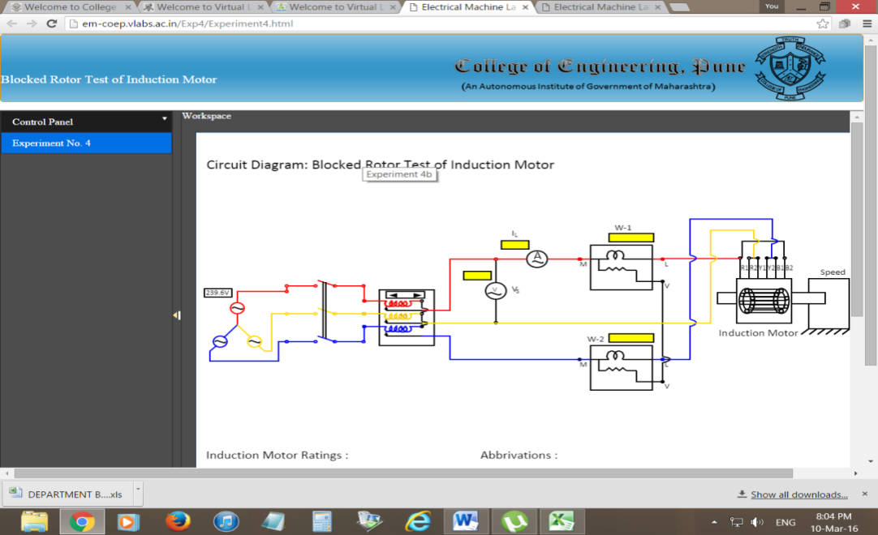
Electrical Machines Virtual Laboratory
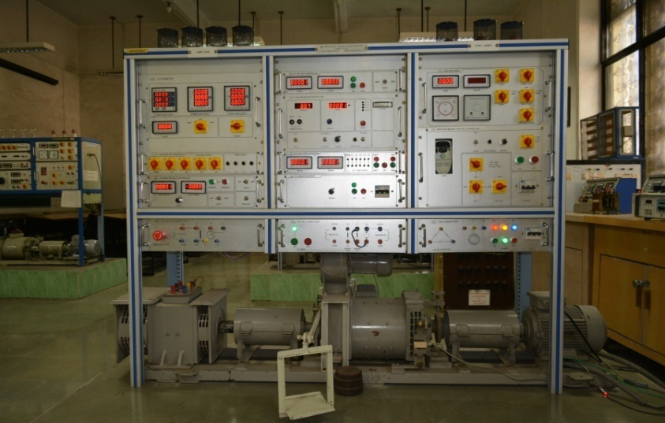
All in one Electrical Machines Test Bench

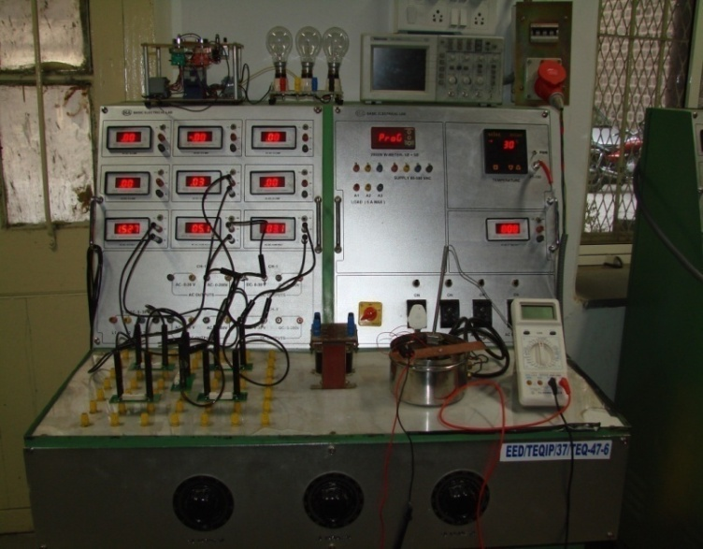
All in one Basic Electrical Machines Laboratory Test Bench

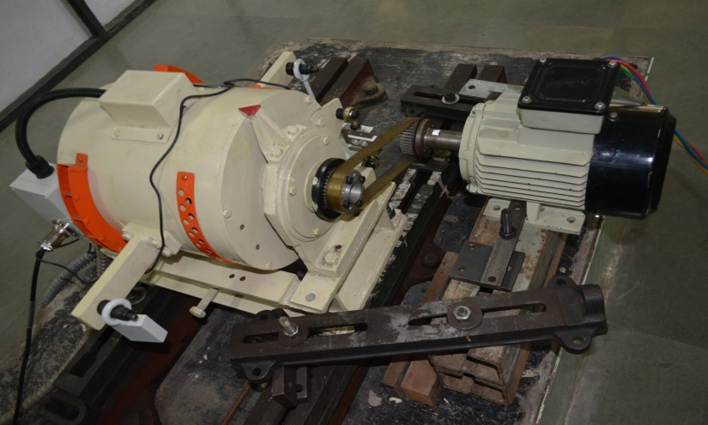
Synchronous machine FHP Dynamometer

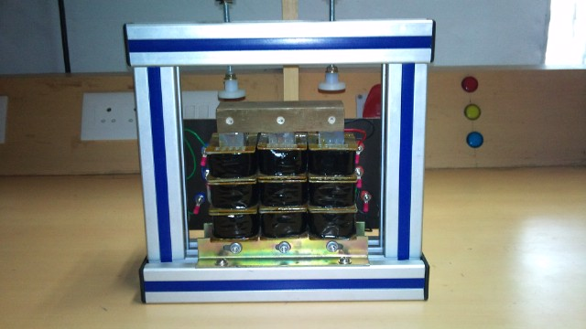
Versatile Multi-purpose 3 limb transformer

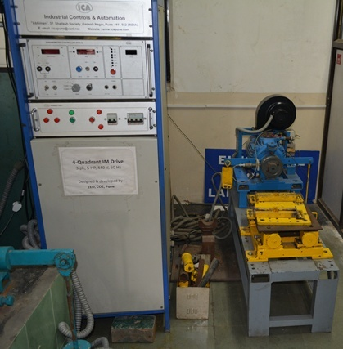
Four Quadrant Induction Machine Dynamometer

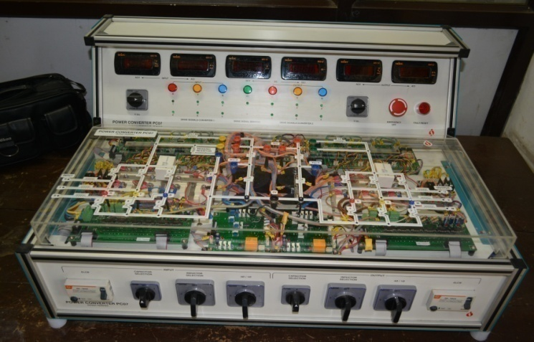
Development of AC-DC-AC Power Converter

