Safety Measures –
College have security check-post at every entry in the college and hostel. Security cabins are located at every security gate in college. Every gate have at least two security guards. CCTV surveillance are provided at every gate.
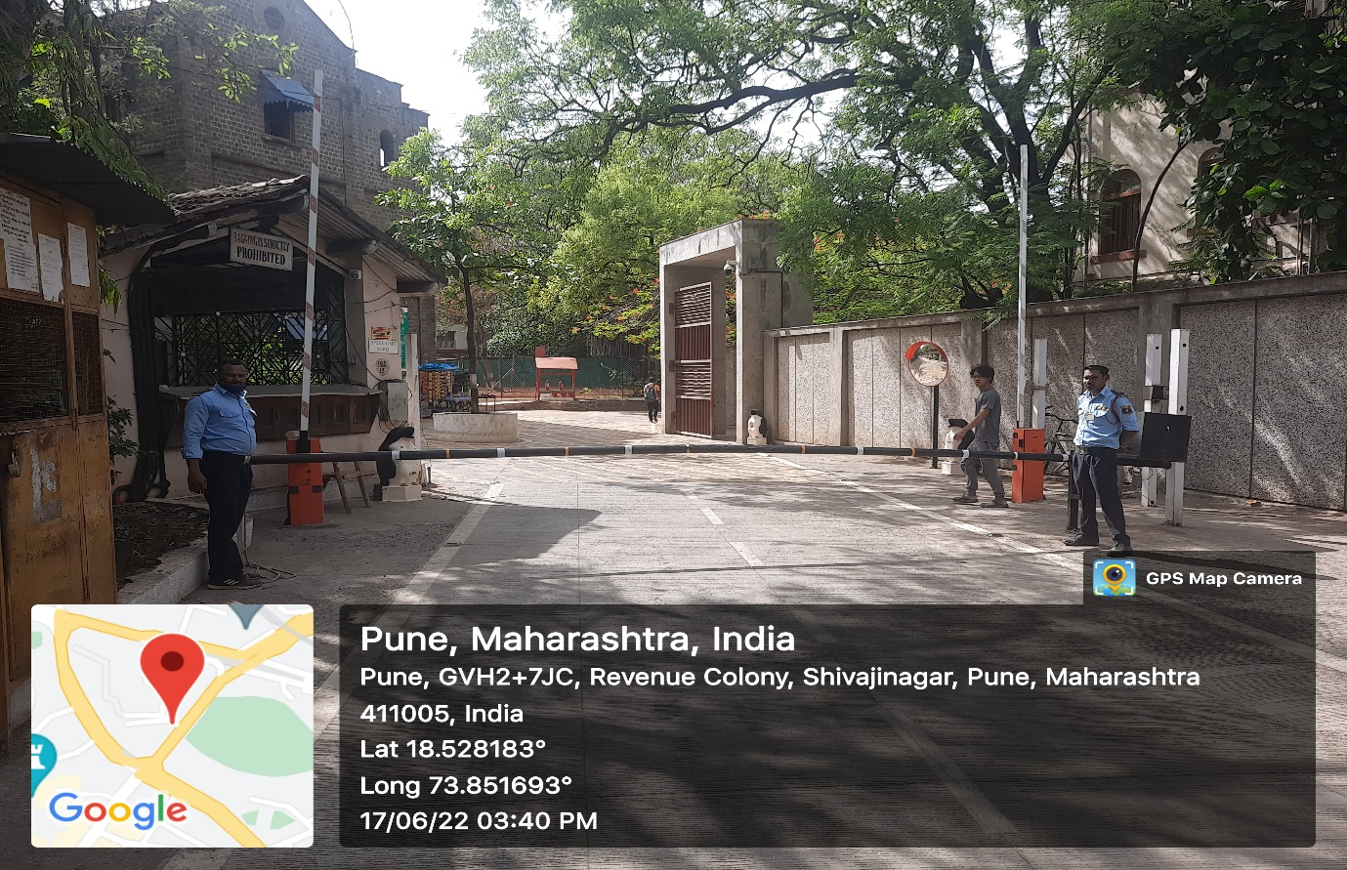
Security Gate
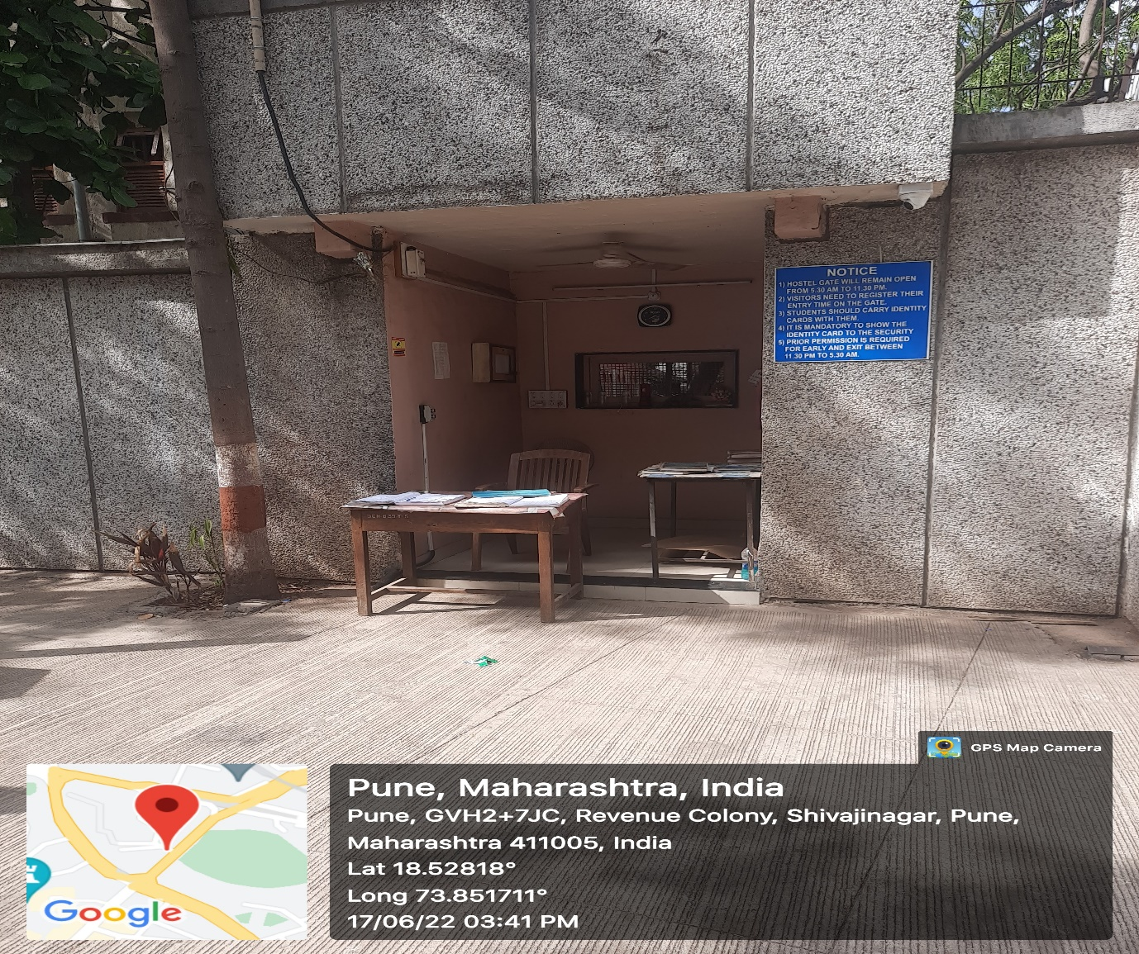
Security Cabin in Hostel
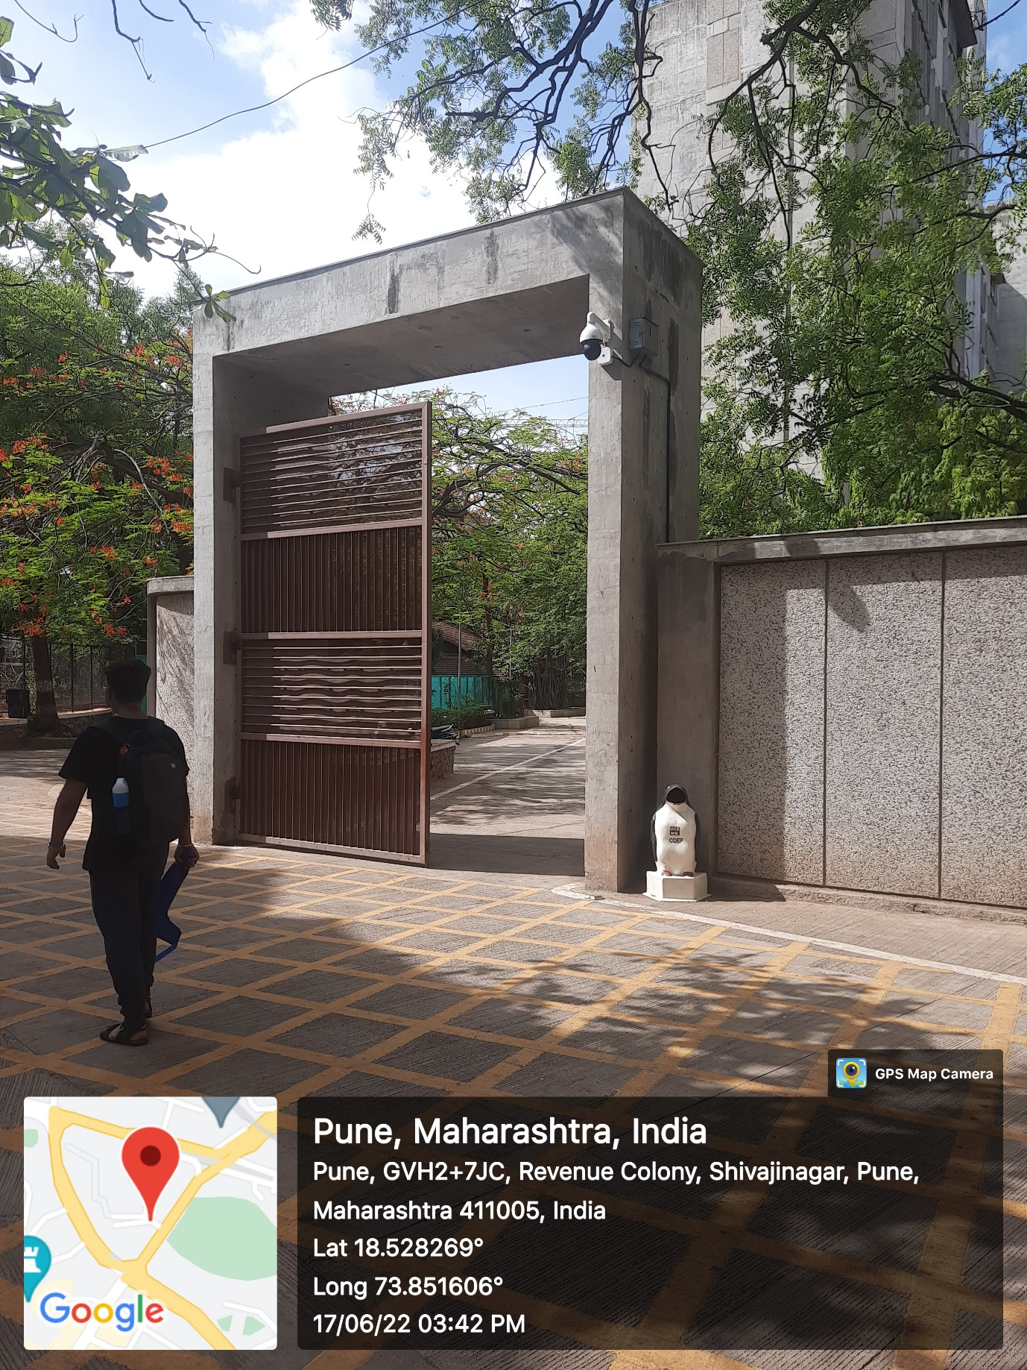
CCTV Camera
COEP college campus and hostel have 24 hour CCTV surveillance at every prime location.
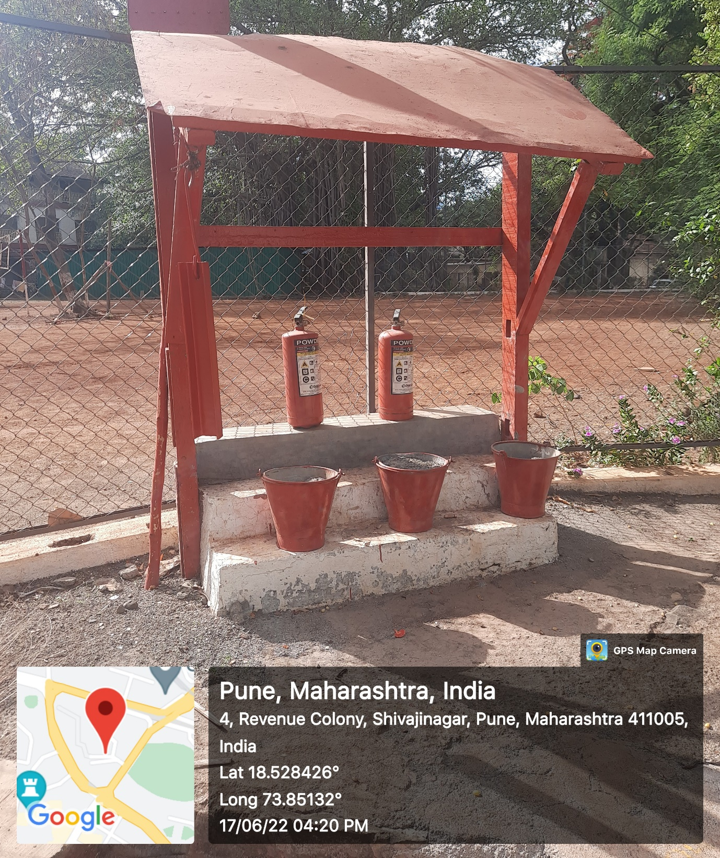
Fire Extinguisher in Hostel

All the buildings of the institution are well protected by fire safety systems.
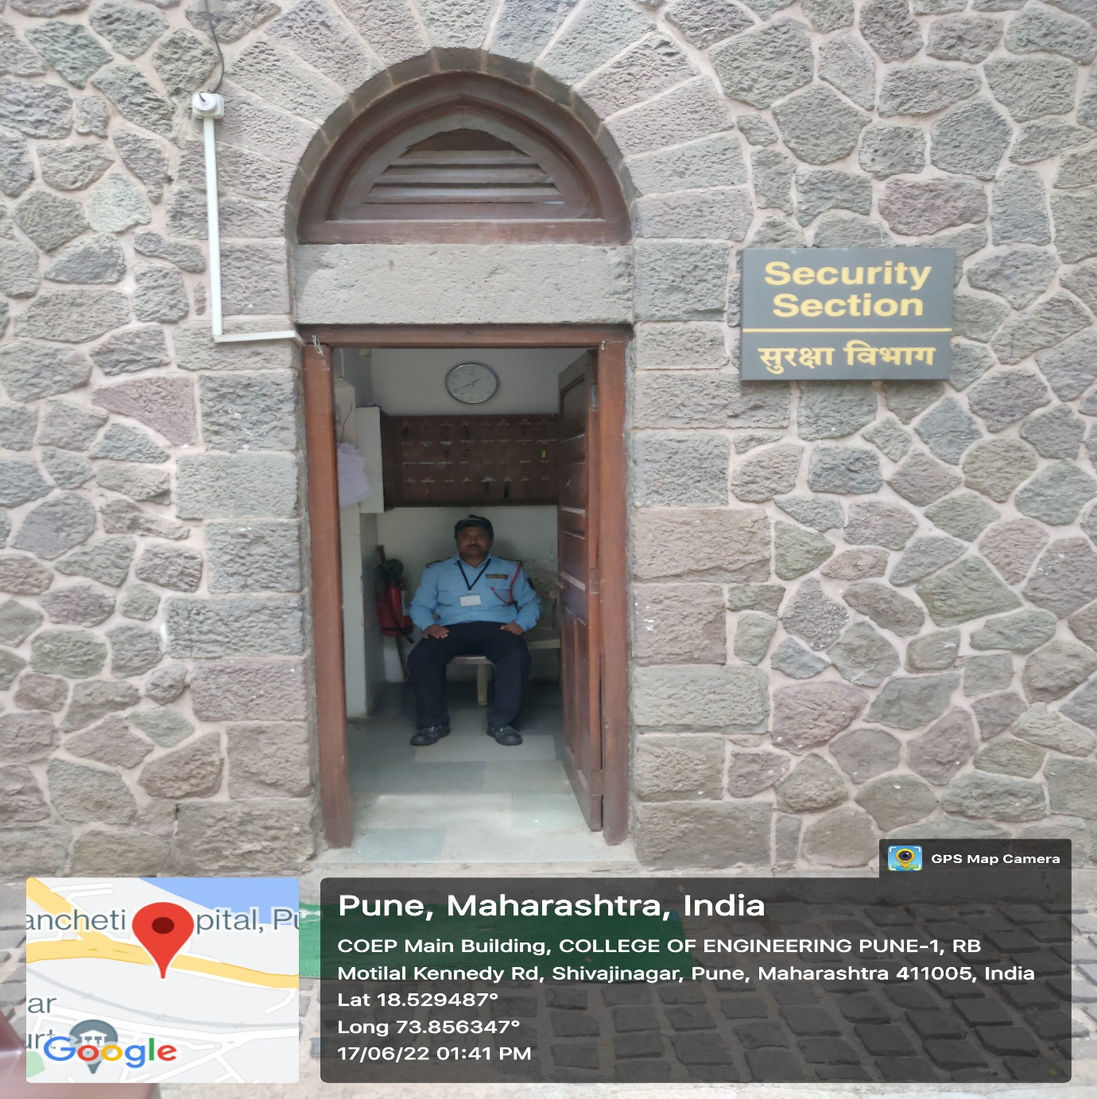
Security Cabin in South Campus
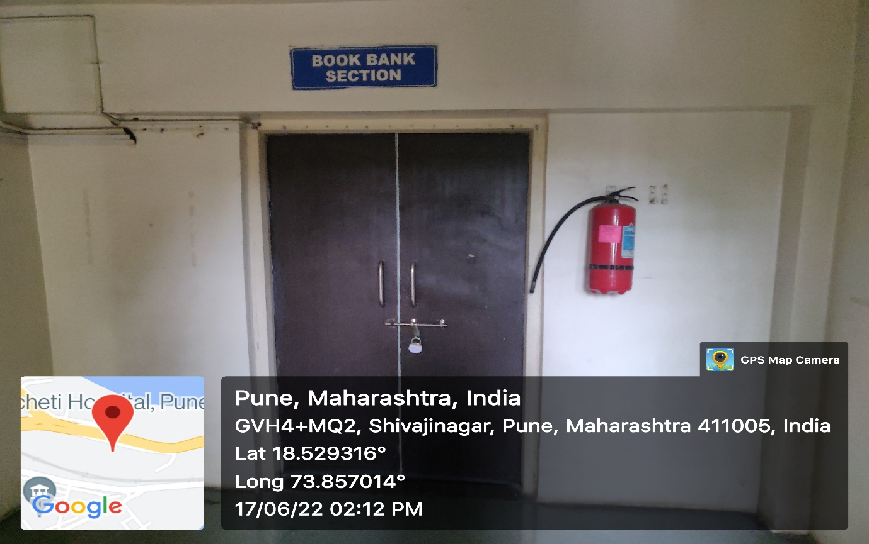
Fire extinguisher outside every office
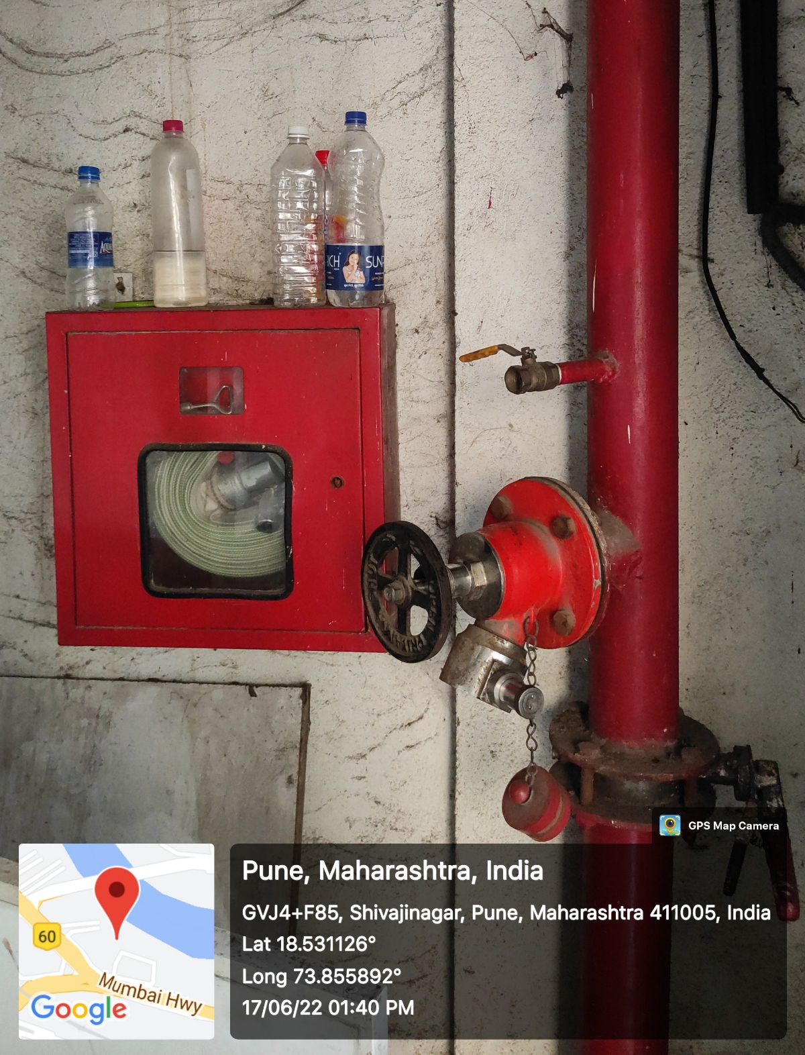
Fire Extinguisher in Academic Complex Building

All the buildings of the institution are well protected by fire safety systems.

