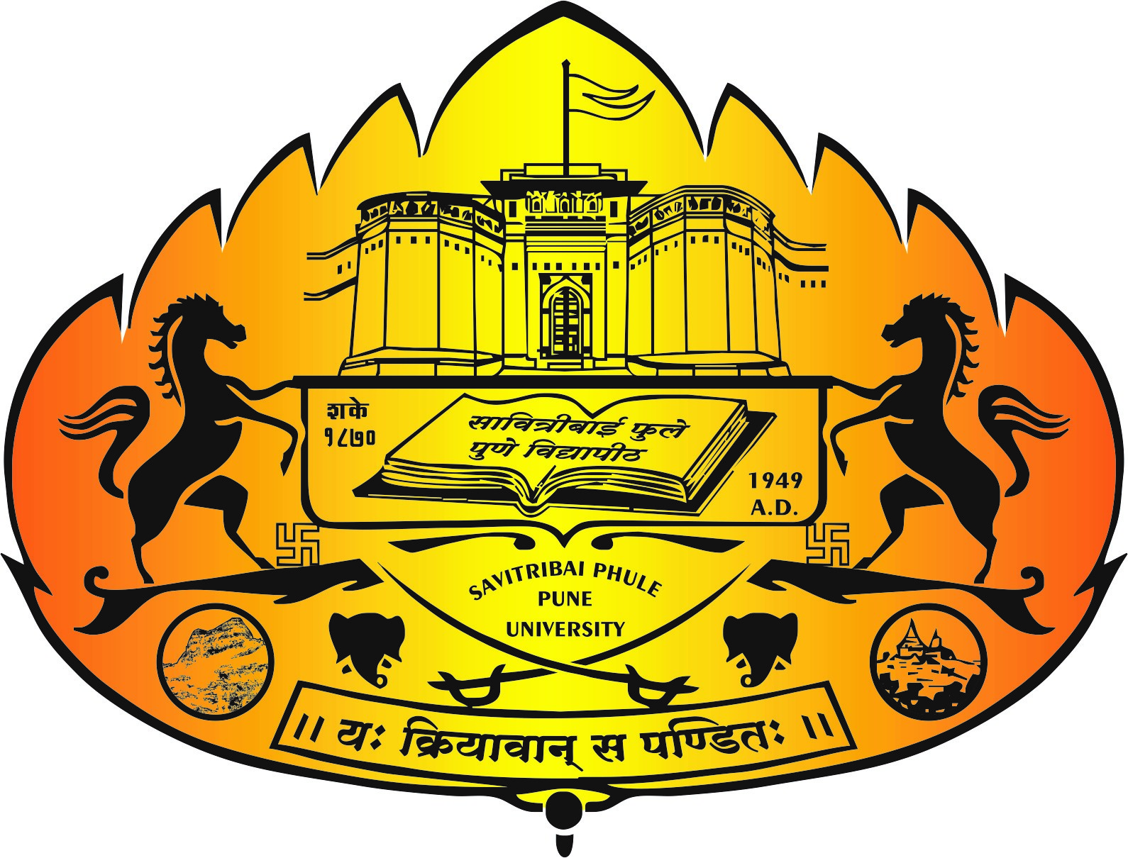
Offers One Year Full-Time Post Graduate Diploma
in
Electric Mobility (PGDEM)

APPLICATION FORM
NOTE: The fields marked with (*) are mandatory
*Full Name:
*Tel. No.(With STD):
*Mobile Number:
*E-Mail:
*Gender:
* Date of Birth
*Parent's/Husband's Name
Parent's/Husband's Email-Id
*Parent's/Husband's Telephone No. with STD code/ Mobile No
*Family Income Per Annum:
*Self-Income Per Annum:
*Permanent Address:
*Pin Code:
*State For Permanent Address
Is Correspondence Address same as Permanent Address Yes/No
*Correspondence Address:
*Pin Code:
*State For Correspondence Address:
* Nationality
* Domicile State of the Candidate

Qualification Details:
Examination | Name of the  Institute/University | Duration  From To | Marks  % | Total No. of  Backlogs
*SSC/Equivalent
(Std.X/level10)
*HSC/Equivalent(Std.XII/level12)

Graduation Details:
Examination | Name of the Institute/  University | Speciali-zation | Duration  From To | Final Year  Marks % | Aggregate  Marks % | Total No. of  Backlogs
*Graduation
- Appeared
- Passed
Post-Graduation
- Appeared
- Passed
Duration of Educational Gaps |  |  | Reason of  Educational Gaps

Professional Experience:
Name of the Employer | Designation | Period  From To |  | Nature of Work
Duration of Professional Gaps |  | Reason of Professional Gaps

Application Fee Details:
*DD Amount (Rs.):
*DD Number:
*DD MICR Code:
*DD Date:
*Bank Name:
(Nationalized/Schedule/Commercial Banks Only)
*Drawee Branch Name:

Date:
Place: Signature of Candidate

Note: This form must accompany application fee of Rs.500/- payable by DD only
Favoring, “Director, College of Engineering, Pune”

Last date for submission of application form: Wednesday, 9th August 2019
Course Commencement: Monday, 19th August 2019

